Date: Monday February 1, 2021
Start Time: 3:00 PM

Participants: Ms. Perez, Ms. Haig, Ms. Hamerman, Ms. Amador, Ms. McKenna, Ms. Rhoden, Ms. Vazquez, Ms. Cortes

3:00 PM- Ms. Hamerman reviews the agenda

3:03 PM- Ms. McKenna reviews SLT minutes from last session/Any questions before moving forward

Principal Report
-An additional 8 classes were brought back for 5 days a week of in-person instruction

Parent Report
-Cookies and Canvas event Feb 10th 6 PM- PSA is giving out paint kits

UFT Chapter Report
-Certain sections of the by-laws need to be reviewed (Open Meeting Law Section- revision to see how to incorporate more of the community at large; communication and clarity)
-We can try to meet as a committee in the next few weeks so that we can have something final and present the revision at our next meeting

Data (Ms. Haig)
-ELA i-Ready Diagnostic given in November 2020
-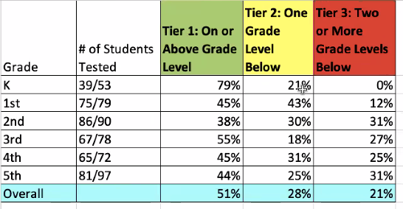
-Fully remote students will be invited to come in school to take the i-Ready diagnostic test
-Window 2 of i-Ready diagnostic will be complete by end of February
-Math i-Ready Diagnostic Data November 2020
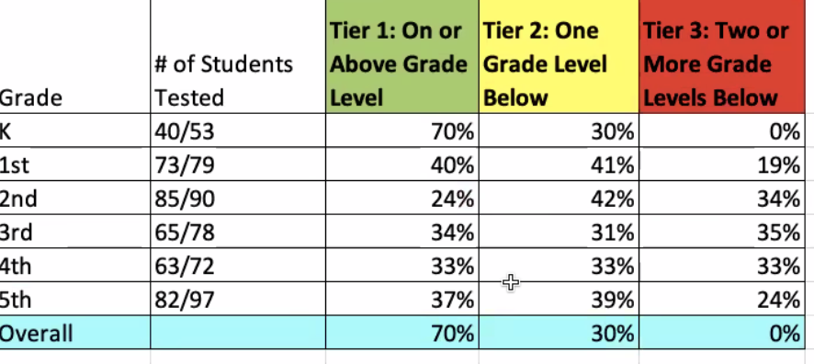

CEP Goals (Ms. Adreina Perez)
-Ms. Adreina Perez explains how we launched a survey in the beginning of the year. Based on the survey results the CEP was modified to reflect the data collected during the survey.
-Top 2 topics on survey were ELA & Math workshops
-Top 2 following were PBL and Social-Emotional workshops
-SLT discussed that parents expressed on the survey that there are too many robocalls back to back for parents to keep up with
-Ms. Perez said we will begin the process of streamlining certain information through specific platforms in order to still get important information out
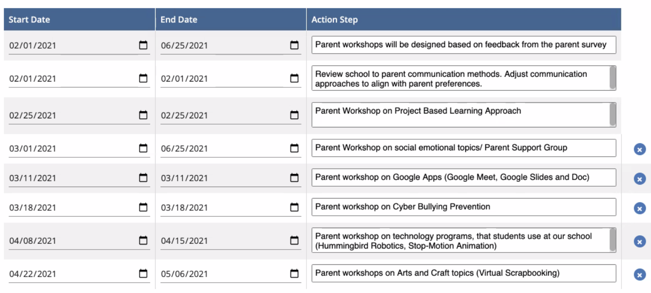

End time: 4:30 PM

